Explanation & Methodology for Dissemination of Client Bond FRA trades reported by market makers

1) RBI has mandated reporting of OTC Bond FRA trades by Market Makers with trades executed with their Clients to CCIL‘s Trade Repository.
2) All New contracts reported unilaterally by Market Makers that pass the basic validation checks at CCIL–TR are considered for dissemination. The subsequent life cycle events like Unwind/Cancellation is not considered for dissemination.
3) The data reported is bifurcated based on Security (G-Sec ISIN) wise Bought/Sold for face value in INR (crores) from Client perspective for various maturity wise (Tenor) buckets. In each tenor bucket, No. of Trades and Volume (INR crores) are disseminated.
4) Considering the confidentiality and sensitivity of Client Trades, the data is disseminated after a lag of seven business days. (May undergo regulatory review)

Trades will be disseminated as per below example
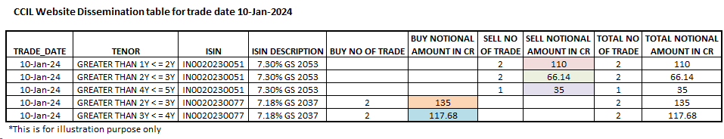
Below are the trades which are being disseminated.

